**St Wilfrid’s Primary School Literature Spine**

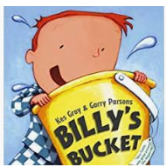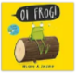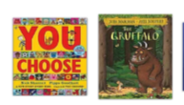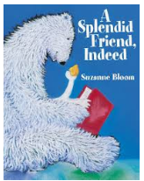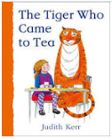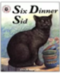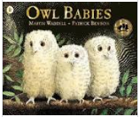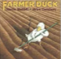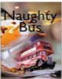To ensure every child is exposed to good quality literature, we have developed our very own literature spine. These books have been chosen as recommended texts and we will try to introduce the children to as many of these books as possible throughout their time at St Wilfrid’s. The purpose of this literature spine is to ensure every child has the experience of storytelling and to help develop a love of reading in every child. This book list is also intended to help parents when choosing books for their children.

**Reception:** We read books everyday but here is a selection of our core reading spine.

The Gruffalo & The Guffalo’s Child – Julia Donaldson

Owl Babies – Martin Waddell

Mr Grumpy’s Outing – John Burningham

The Naughty Bus – Jan and Jerry Oke

Six Dinner Sid – Inga Moore

Mrs Armitage – Quentin Blake

Farmer Duck – Martin Waddell

Shhh! – Sally Grindley

Oi Dog – Kes Gray

The Pea and the Princess – Mini Grey

Owl Babies – Martin Waddell

Where the wild things are – Maurice Sendak

The Lion Inside – Rachel Bright

Knuffle Bunny, Knuffle Bunny 2 - Mo Williams

I want my Potty – Tony Ross

Handa’s Surprise – Eileen Brown

The Leopards Drum – Jessica Souhami

The Tiger who came to Tea – Judith Kerr

A Splendid Friend Indeed – Suzanne Bloom

The Lighthouse Keeper series –Ronda and David Armitage

Indian Tales – Barefoot Books

Chandra’s Magic Light – Barefoot Books

Billy’s Bucket – Kes Gary

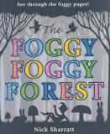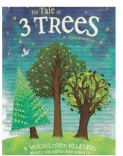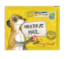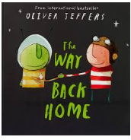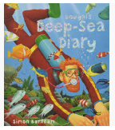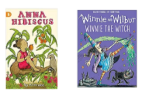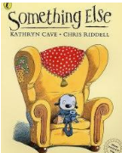

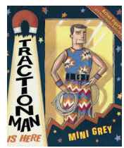

**Year 1 :** We read books everyday but here is a selection of our core reading spine.

Lila and the Secret of Rain – David Conway and Jude Daly

Dougal’s Deep Sea Diary – Simon Bartram

Not Now Bernard – David McKee

Meerkat Mail – Emily Gravett

Traction Man – Mini Grey

I Want My Hat Back – Jon Klassen

Click, Clack, Moo: Cows That Type – Doreen Cronin

The Way Back Home – Oliver Jeffers

Gorilla – Anthony Browne

Dear Greenpeace – Simon James

The tales of Three Trees – Angela Elwell

Foggy, Foggy Forest – Nick Sharratt

Something Else – Kathryn Cave

Marty Monster – Malorie Blackman

Starlight – Gillian Lobel

Stuck – Oliver Jeffers

Pumpkin Soup – Helen Cooper

Grandad’s Secret Giant – David Litchfield

Ruby’s worries – Tom Percival

The Pig and the Porker – Peter Bently & David Roberts

We read a range of traditional and twisted traditional tales.

We also share a variety of Bible Stories throughout the year e.g. Nick Butterworth – Stories Jesus Told

Poetry

Mustard, Custard, Grumble Belly and Gravy – Michael Rosen and Quentin Blake

The Puffin Book of Fantastic First Poems – edited by June Crebbin

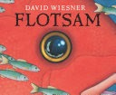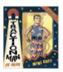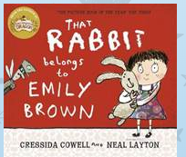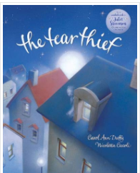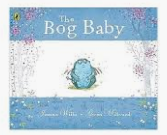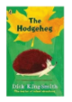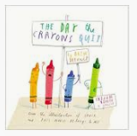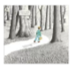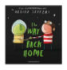

**Year 2**

The True Story of the Three Little Pigs – Jon Scieszka

Tadpole’s Promise – Jeanne Willis

Dr Xargle’s Book of Earthlets – Tony Ross

The Day the Crayons Quit – Drew Daywalt and Oliver Jeffers

Once Upon an Ordinary School Day – Colin McNaughton

The Incredible Book Eating Boy – Oliver Jeffers

The Mousehole Cat – Antonia Barber and Nicola Bayley

The Dark – Lemony Snicket and Jon Klassen

The Hodgeheg – Dick King Smith

Who’s afraid of the big bad book? – Lauren Child

Tuesday – David Weisner

Three by the Sea – Mini Grey

Emily Brown and the Thing – Cressida Cowell

Malala’s Magic Pencil – Malala Yousafzai

The Bog Baby – Jeanette Willis

Captain Flynn and the pirate dinosaurs – Giles Andreae

The Cat in the Hat – Dr Seuss

Clarice Bean That’s Me – Lauren Child

The Tear Thief – Carol Anne Duffy

That Rabbit belongs to Emily Brown – Cressida Cowell

Flotsam – David Weinser

**Poetry**

A Children’s Treasury of Milligan – Spike Milligan

Jim, A Cautionary Tale – Hillarie Bell & Mini Grey

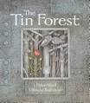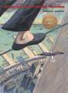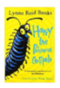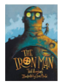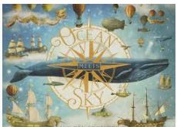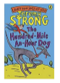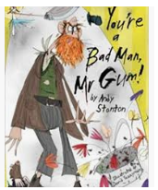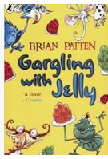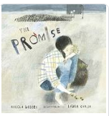

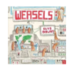

**Year 3**

Mirror – Jeannie Baker

The Tin Forest – Helen Ward

Ocean meets Sky – The Fan brothers

Stone Girl, Bone Girl – Laurence Anholt

Weasels – Elys Dolan

The Boy who grew Dragons – Andy Shepherd

The Promise – Nicola Davies

The Adventures of the Dish and the Spoon – Mini Grey

Into the Forest – Anthony Browne

Gregory Cool – Caroline Birch

One Dog and His Boy – Eva Ibbotson

Charlotte’s Web – E B White

Diary of a Killer Cat – Anne Fine

How to wash a woolly mammoth - Michelle Robinson

The Iron Man – Ted Hughes

The Abominables – Eva Ibbotson

The man who walked between the two towers – Mordicai Gerstein

Harry & the poisonous centipede – Lynne Reid Banks

The Nothing to see here Hotel – Steven Butler & Steven Lenton

**Poetry**

Gargling with Jelly – Brian Patten

Four O’clock Friday – John Foster

Pumpkin Grumpkin – John Agard and Grace Nichols

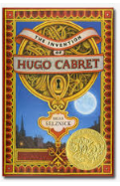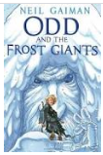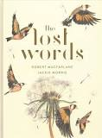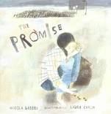

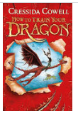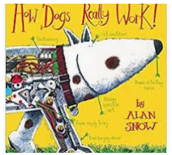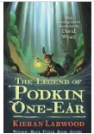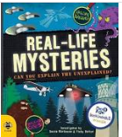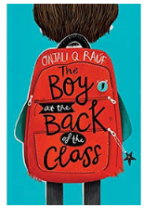

**Year 4**

The Boy in the back of the class – Onjali Q Rauf

The Lion, the Witch and the Wardrobe – C.S. Lewis

Marshall Armstrong New to our School – David Mackintosh

The White Fox – Jackie Morris

How Dogs Really Work – Alan Snow

Beowulf – Michael Morpurgo

How to Train a Dragon – Cressida Cowell

Invention of Hugo Cabret – Brian Selznick

The Wonder Garden – Jenny Broom

Rabbits – Emily Gravett

Wilfred Gordon McDonald Partridge – Mem Fox

The Lost Happy Endings – Carol Ann Duffy

The Legend of Podkin one Ear – Kieran Larwood

Odd and the Frost Giants – Neil Gaiman

Mysterious Traveller – Mal Peet

The Big Book of Blue – Yoval Zomar

Until I met Dudley – Roger McGough

The Promise – Nicola Davies

**Poetry**

Crazy Mayonnaisy Mum – Julia Donaldson

Where Zebras go – Sue Hardy Dawson

Be the Change – Poems that help save the World – Liz Brownlee

Roger Stevens, Matt Goodfellow

The Lost Words – Jackie Morris

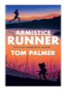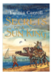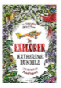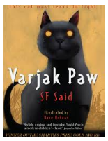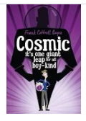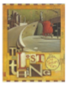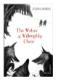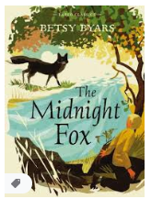

**Year 5**

The Red Tree – Shaun Tan

The Midnight Fox – Betsy Byars

Cold Tom – Sally Prue

The Conch Bearer – Chitra Banerjee Divakaruni

Cosmic – Frank Cottrell Boyce

The Lost Thing – Shaun Tan

Pig Heart Boy – Malorie Blackman

Varjak Paw – SF Said

Wonderstuck – Brian Selznick

The Turbulent Term of Tyke Tyler – Gene Kemp

Journey to the River Sea – Eva Ibbotson

Once – Morris Gleitzman

Journey to Jo’burg – Beverly Naidoo

The Secrets of the Sun King - Emma Carroll

The Wolves of Willoughby Chase – Joan Aitken

The Explorer – Katherine Rundell

The Armistice Runner – Tom Palmer

Charlie and the Chocolate Factory – Roald Dahl

**Poetry**

The Highwayman – Alfred Noyes

Talking Turkeys – Benjamin Zephaniah

New and Collected Poems for Children – edited by Carol Ann Duffy

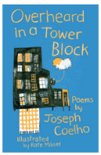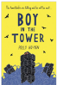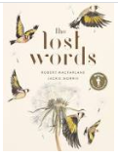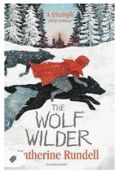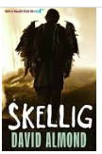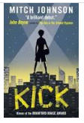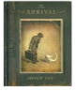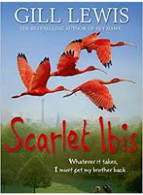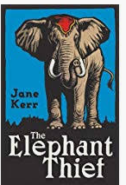

**Year 6**

The Arrival – Shaun Tan

Skellig – David Almond

The Windsinger – William Nicholson

Scarlett Ibis – Gill Lewis

Trash – Andy Mulligan

Wolf Brother – Michelle Paver

The Garbage King – Elizabeth Laird

Private Peaceful – Michael Morpurgo

The Giver – Lois Lowry

Goodnight Mr Tom – Michelle Magorian

The Elephant Thief – Jane Kerr

Kick – Mitch Johnson

The Boy in the Tower – Polly

The Wolf Wilder – Katherine Rundell

The Arrival - Shaun Tan

**Poetry**

The Lost Words – Robert MacFarlane

The Oldest Girl in the World – Carol Ann Duffy

Overheard in a Tower block – Joseph Coelho

If: A Treasury of Poems for Almost Every Possibility – edited by Allie Esiri and Rachel Kelly