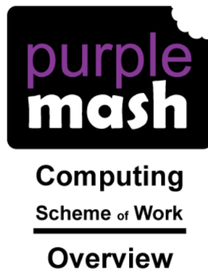The scheme has been adapted by the school. In some areas we have supplemented the scheme with our own planning using Microsoft programmes in order to prepare children for secondary and real-life settings. Modules vary in length.

